CO2-ASSIGNMENT 3
CSA0653 Design and Analysis of Algorithms for complex Problem
BY
Saimeera D(192524405)

Q1. E-Commerce Product Sorting System (Merge Sort) – 50 Marks
Problem Analysis
An e-commerce platform such as Amazon or Flipkart manages millions of products. Products must be sorted based on:
- Price
- Ratings
- Popularity
- Customer reviews
Efficient sorting ensures:
- Fast product search
- Better user experience
- Reduced response time
- Accurate ranking of products
For large datasets, Merge Sort is an excellent choice because of its predictable performance.

Key Challenges
1. Stability
A sorting algorithm is stable if products with equal prices maintain their original order.
Example:
Product | Price | Rating
A | 500 | 4.8
B | 500 | 4.5
C | 700 | 4.7
After sorting by price:
Product | Price
A | 500
B | 500
C | 700
The relative order of A and B remains unchanged.
Merge Sort is naturally stable.

2. Scalability
E-commerce databases may contain:
- Thousands of products
- Millions of products
- Frequent updates
Merge Sort efficiently handles large datasets due to its consistent performance.

3. Memory Usage
Merge Sort requires temporary arrays during merging.
For n elements:
[
Space = O(n)
]
Extra memory is needed, but the gain in sorting speed justifies the trade-off.

Divide and Conquer Approach
Merge Sort follows Divide and Conquer.
Step 1: Divide
[80, 40, 60, 20, 10, 70]
|
------------------
| |
[80,40,60] [20,10,70]
Step 2: Recursively Divide
[80,40,60]
/ \
[80] [40,60]

[20,10,70]
/ \
[20] [10,70]
Step 3: Merge
[80] + [40] -> [40,80]

[10] + [70] -> [10,70]

[20] + [10,70]
↓
[10,20,70]
Final Merge
[40,60,80] + [10,20,70]

↓

[10,20,40,60,70,80]

Merge Sort Algorithm
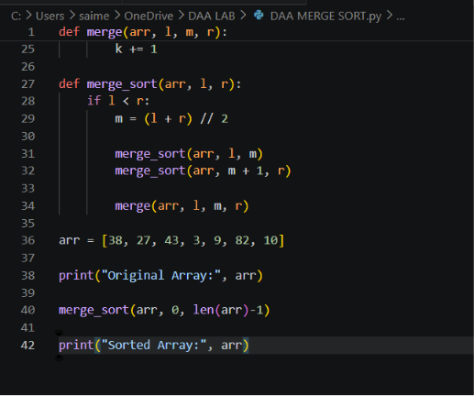
Complexity Analysis
Best Case
[O(n\log n)]
Average Case
[O(n\log n)]
Worst Case
[O(n\log n)]

Space Complexity
[O(n)]

Performance Analysis
Dataset Size | Merge Sort Performance
1,000 | Fast
10,000 | Very Fast
100,000 | Efficient
1,000,000+ | Highly Suitable
Unlike Quick Sort, Merge Sort never degrades to O(n²).

Innovative Solution
For huge e-commerce databases:
Parallel Merge Sort
Different servers sort separate chunks simultaneously.
Server 1 → Product Set 1

Server 2 → Product Set 2

Server 3 → Product Set 3

Server 4 → Product Set 4
Then merge results.
Benefits:
- Faster execution
- Better scalability
- Cloud-friendly architecture

Justification
Merge Sort is suitable because:
Stable sorting
Guaranteed O(n log n)
Handles large datasets efficiently
Supports distributed processing
Ideal for product ranking systems

Conclusion
Merge Sort provides reliable and scalable sorting for e-commerce platforms. Its stability, predictable performance, and divide-and-conquer design make it highly effective for sorting millions of products by price and ratings.

Q2. Real-Time Ranking System (Quick Sort) – 50 Marks
Problem Analysis
A real-time ranking system continuously updates scores.
Examples:
- Online gaming leaderboards
- Exam ranking systems
- Sports rankings
- Social media popularity rankings
Requirements:
- Fast sorting
- Frequent updates
- Immediate ranking display
Quick Sort is highly efficient because of its excellent average-case performance.

Key Challenges
1. Pivot Selection
The pivot determines partition quality.
Bad pivot:
[10,20,30,40,50]
Pivot = 10
Produces:
[]
[20,30,40,50]
Highly unbalanced partitions.

2. Dynamic Updates
Scores continuously change.
Example:
User A = 950
User B = 870
User C = 920
After update:
User B = 980
Leaderboard must be re-sorted quickly.

3. Worst Case Behavior
If pivot selection is poor:
[
O(n^2)
]
This becomes inefficient for large leaderboards.

Divide and Conquer Process
Consider:
[75,20,90,60,30]
Choose Pivot = 60
Partition
[20,30] 60 [75,90]
Recursively Sort
[20,30]

[75,90]
Final Output
[20,30,60,75,90]

Quick Sort Algorithm
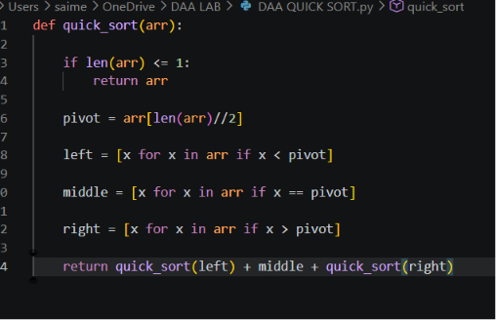
Randomized Pivot Optimization
Instead of fixed pivot:
import random

pivot = arr[random.randint(0, len(arr)-1)]
Advantages:
- Reduces probability of worst case
- Produces balanced partitions
- Improves performance consistency

Complexity Analysis
Best Case
Balanced partitions:
[O(n\log n)]
Average Case
[O(n\log n)]
Worst Case
[O(n^2)]
Occurs when partitions become extremely unbalanced.

Space Complexity
Average recursion stack:
[O(\log n)]
Worst case:
[O(n)]

Performance Under Different Inputs
Input Type | Performance
Random Data | Excellent
Large Rankings | Excellent
Sorted Data (Bad Pivot) | Poor
Randomized Pivot | Excellent
Repeated Updates | Fast

Optimized Real-Time Solution
Randomized Quick Sort
1. Randomly choose pivot.
2. Partition data.
3. Recursively sort partitions.
4. Update leaderboard.
Additional Enhancement
For continuous updates:
- Maintain ranking cache.
- Re-sort only affected sections.
- Combine Quick Sort with priority queues or balanced trees.
Benefits:
Faster updates
Reduced computation
Better scalability

Justification
Quick Sort is suitable because:
Very fast average performance
Excellent cache utilization
Low memory overhead
Efficient for dynamic ranking systems
Randomized pivot minimizes worst-case situations

Conclusion
Quick Sort is an effective choice for real-time ranking systems due to its average-case O(n log n) performance and low memory usage. By using randomized pivot selection and efficient update strategies, the system can maintain fast and accurate leaderboards even under continuous score changes.

